CRICOS Provider No. 00103D | RTO Code 4909

Weekly UX Tasks 1 to 3 (UX Analysis)
Student Name: Adeola Ayeni
Student ID: 30451462

Tutorial 01 - Introduction to UX and Product Objectives

Part 1:

a) User Experience (UX)
I used to think that user experience was primarily about the visual appeal and overall feel of a service or product, leaving users with a delightful experience that fosters loyalty. My focus was mainly on the design features and their aesthetic qualities, rather than considering the entire functionality of the product. I now recognise that the design should also prioritise simplicity and ease of use to enhance the overall experience when interacting with the product or service.

b) “Adeola Fan-switch”
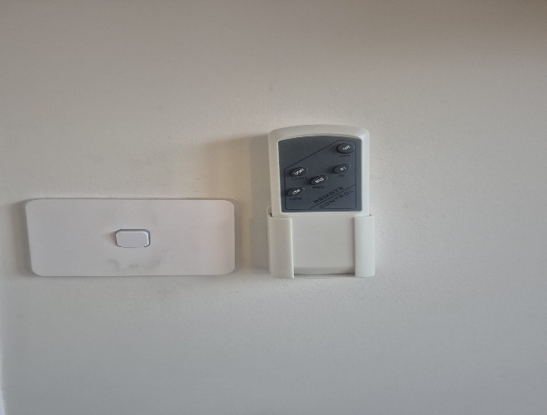

This fan control system is different from standard ceiling fan controls, as it requires you to first turn the wall switch on or off before using the remote to adjust the fan speed. There are only three speed settings available. One frustrating aspect of this setup is that the switch for the remote looks very similar to the switch that controls the light bulbs. As a result, when attempting to turn on the lights, you might accidentally activate the fan switch instead, leaving the light bulbs off. Additionally, the fan speed is limited to just three options. This relates to the affordance and visibility principle and impacts efficiency and learnability.

c) Your Proposed Solution

To reduce frustration with the fan control system, a redesign of the wall switches is proposed to make it easier to distinguish the fan switch from the light switch. This can be achieved by using different colours or icons, such as a fan symbol, on the switch plate. This visual distinction would help users quickly identify which switch controls the fan and which controls the light, thereby minimising accidental activation. Additionally, integrating fan speed control directly into the wall switch or allowing the remote control to operate independently of the wall switch would enhance overall efficiency.

Part 2:

Random Scenario
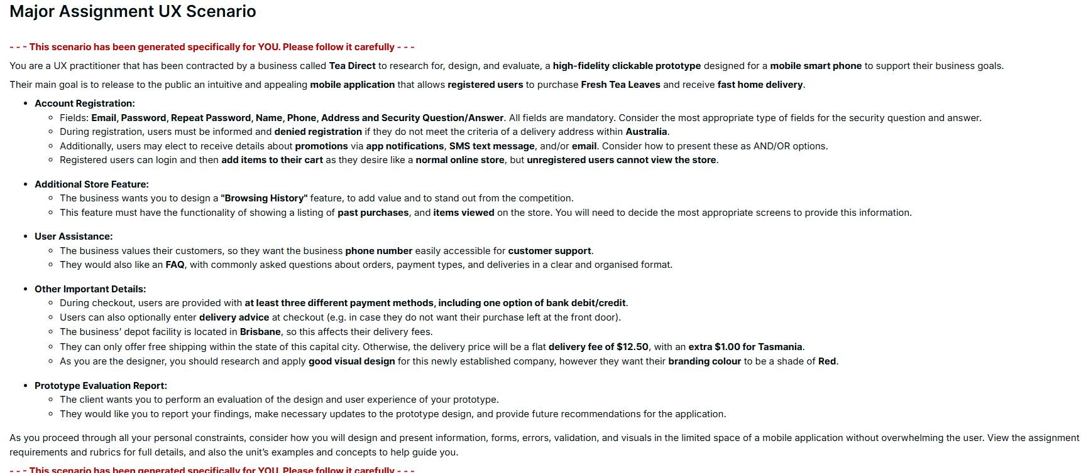

Product Objectives
1. Project Overview
The project aims to create a user-friendly mobile application for Tea Direct, enabling registered customers to purchase fresh tea leaves for home delivery across Australia easily. The app will serve as the main platform for browsing products, managing accounts, placing orders, and receiving personalised support. Our goal is to enhance the customer experience, expand market reach, and increase revenue through a seamless and intuitive purchasing process.

2. Business Objectives
2.1 Revenue Growth and Market Expansion
A mobile app that provides a convenient channel to increase reach across Australia and encourages repeat purchases.
Objective: To increase online sales revenue by 25% within 12months, acquiring customers across the 5 Australian states and territories.

  - Reduce Operational Load
Transitioning orders to a mobile platform reduces the manual processing and administrative workload.
Objective: To reduce operational order-processing cost by 20% within 12 months of launch

- User Objectives
  - Enhanced User Experience
Users expect fast, simple, mobile-friendly interfaces when shopping online.
Objectives: To achieve a task completion time of 3 minutes for adding an item and checking out. (Andersen, G. 2024)

3.2 Easy and Secure Account Registration
Registration is mandatory to access the store, so the process must be seamless.
Objective: To convert 85% success rate of app downloads into completed registrations. (Andersen, G. .2024)

4 Product Design Objectives
4.1 Intuitive Registration
Users must register before accessing the store; validation and clarity are essential.
Objective: Reduce registration errors to 5% and ensure 100% mandatory field validation

4.2 Seamless Checkout and Payment
Multiple payment options increase transaction success.
Objective: To reduce failure rates to below 70% within 6 months (Andersen, 2024)

5 Key Performance Indicators (KPIs)
- Monthly online sales increase
- Average task completion time
- Monthly active user
- Registration success rate
- New Customer Registration
- Customer satisfaction rating
- Customer service call reduction

Tutorial 02 - Users, Usability and User Personas

Part 1:

a) Digital Interfaces
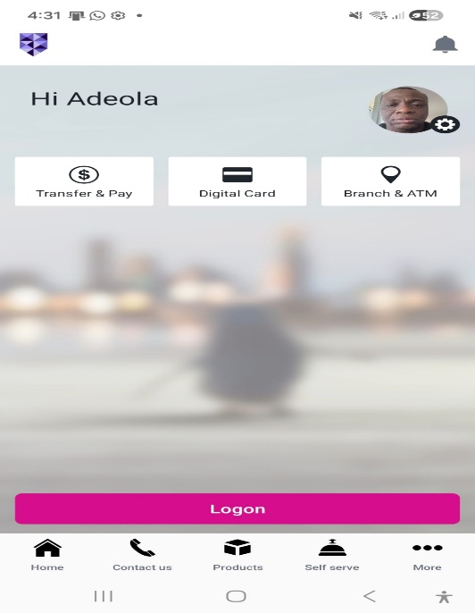
A Banking Interface
A digital interface I often use that can be frustrating at times is my mobile banking application. One significant issue is the complex navigation structure for performing simple tasks. Important features, such as transfer history and scheduled payments, are buried within multiple menus, making these straightforward tasks unnecessarily time-consuming.
Another problem I’ve noticed is that it sometimes takes several seconds to process a payment without displaying a clear loading indicator. This lack of feedback leaves me unsure whether the action was successful. These usability issues create confusion and reduce efficiency, forcing me to double-check my actions and spend extra time completing simple banking tasks.

b) Usability Goals
The banking app performs inconsistently when evaluated against the six usability goals.
- Effectiveness: The functions sure work, but users must navigate through several screens
- Efficiency: It is poor because tasks such as transferring funds require too many steps.
- Safety: It is good because confirmations are required before payments are sent.
- Utility: It is strong because it has many banking features
- Learnability: It is limited due to too many confusing menus
- Memorability: I is weak because users must frequently relearn where functions are located.

c) Excellent Operation
One of the common objects I use every day is my mobile phone, which features a fingerprint unlock function. Previously, I used to unlock my phone with a password or PIN. However, with the fingerprint unlocking capability, accessing my phone has become much easier and faster, eliminating the need to remember a password or PIN. This feature is so efficient that it involves no learning or memorisation; I place my finger on the designated spot for recognition. It is also safe to use, as it prevents unauthorised users from accessing my phone. Overall, my experience with this feature has been entirely positive.

Part 2:

a) User Personas
- Name: Sarah Mitchell
Age: 38
Location: Sydney, New South Wales
Education: Bachelor’s degree in business
Occupation: Marketing Manager

Story
Sarah works long hours in a corporate marketing role. She prefers healthy beverages and enjoy premium teas but rarely has time to visit speciality tea stores. She prefers ordering online and having products delivered quickly to her apartment.
Goals
- Quickly purchase high-quality fresh tea leaves that fit her busy lifestyle
- Maintain a healthy routine with premium teas.
- Simple payment methods
Needs
- Delivery tracking and notifications.
- Fast checkout and secure payment options
Wants
- Recommendations for popular or trending teas.
- Premium and organic tea varieties.
- Loyalty rewards for frequent purchases
Fears
- Receiving low-quality or stale tea leaves
- Delayed deliveries that disrupt her schedule.
- Complicated or slow mobile app interfaces.
Pain Points
- Limited time to shop in-store
- Too many steps in the ordering process.
- Lack of transparency in delivery times.

- Name: Margaret Wilson
Age: 67
Location: Perth, Western Australia
Education: Degree in Nursing
Occupation: Retired Nurse

Story
Margaret Wilson is a 67-year-old retired nurse living in Western Australia who enjoys a quiet lifestyle after decades of caring for patients. She spends her time gardening, walking along the coast and relaxing with a cup of tea. To make life easier, Margaret often uses simple mobile apps to order groceries and specialty tea delivered to her home.
Goals
- Conveniently purchase fresh tea leaves without travelling to specialty shops
- Maintain her daily tea-drinking routine.
- Access affordable pricing for larger orders.

Needs
- Simple and easy to navigate app interface.
- Clear product descriptions and large, readable text
- Reliable delivery service.
Wants
- Traditional tea varieties she is familiar with.
- Ability to place orders easily without complicated steps.
- Customer support or assistance when needed.
Fears
- Difficulty understanding how to use the app.
- Making mistakes while placing orders.
- Online payment security concerns.
Pain Points
- Limited access to specialty tea shops nearby.
- Small text and complex app designs.
- Confusion during checkout processes.

- Name: Liam ‘O Connor
Age: 21
Location: Brisbane, Queensland
Education: Undergraduate student
Occupation: Student

Story
Liam is a university student who enjoys drinking tea while studying or gaming late at night. He prefers quick online purchases through mobile apps and is attracted to modern brands and unique flavours.
Goal
- Orders affordable tea quickly from his phone for daily consumption
- Try new flavours and trendy tea blends
- Get student-friendly deals and promotions
Needs
- Fast and simple mobile ordering process
- Affordable prices with student discounts
- Multiple digital payment options
Wants
- Discounts, student deals, and Promotions.
- Recommendations for popular or trending teas
- Quick delivery to student accommodation
Fears
- Spending too much on premium tea products.
- Ordering the wrong product due to unclear descriptions.
- Unexpected delivery fees.

Pain
- Long delivery times
- Difficulty finding good-quality tea locally.
- Limited budget for specialty tea

- Generative AI Prompts
AI Tool: ChatGPT
Purpose: Used to assist in generating initial ideas for user personas and story descriptions for the mobile application design task
- Prompt Used: “I am designing a mobile app for a business organisation that deals in the delivery of Fresh Tea leaves across the various states and territories of Australia. Please, create three unique user personas with diverse demographics”
- Conversation Link:
https://chatgpt.com/s/t_69b799bc8f688191834d94d347a234c7
- Prompt Used: “Can you structure the user personas along the features of goal, needs, wants, fears and pains?”
- Conversation Link:
https://chatgpt.com/s/t_69b799ffd380819185ad2bafa078021a
- Prompt Used: “Can you structure user personas along different occupations such as professionals and non-professionals?”
Conversation Link:
https://chatgpt.com/s/t_69b7a6c72ecc8191b1604dc99f1ff6c8
- Prompt Used: “Can you structure user personas along different age groups with a wider age range among them?”
Conversation Link:
https://chatgpt.com/s/t_69b76986e26c8191b46e24294034db01

Tutorial 03 - Patterns, Principles and User Tasks

Part 1:

a) Deceptive Patterns
Amazon Prime Delivery
- I purchased an item on Amazon and proceeded to the checkout stage, where I was asked if I wanted a faster delivery at no additional cost. However, this option was not explicitly stated to incur an additional cost in later months as a recurring monthly fee.
- The business gained a monthly subscription to the online streaming platform Amazon Prime.
- No, it has not been changed. Anyone who didn’t want the addition of an online streaming service at an extra recurring monthly fee will have to go back to the platform and unsubscribe from the service.

b) Interaction Design Principles
Fridge (Refrigerator)
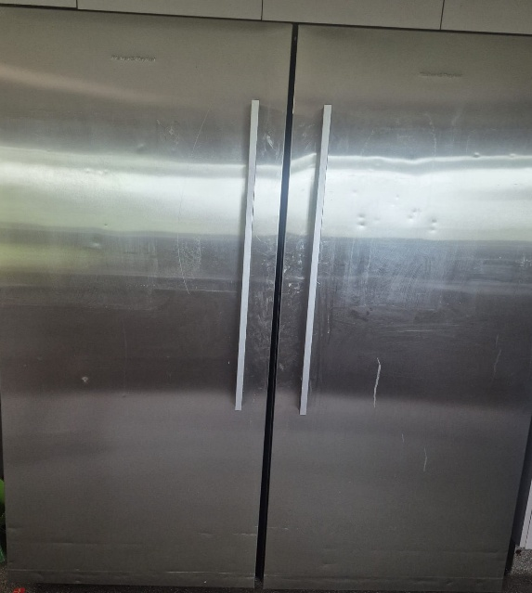
- Affordance: The fridge has a handle that suggests that it needs to be pulled to open the fridge, it also has shelves that suggest that food items can be placed in them and sliding drawers which suggest that it can be pulled in and out.
- Visibility: The fridge handle, drawers and shelves compartments are visible, showing how users should interact with it. It also has temperature displays and a control panel, which can indicate the temperature setting and can also be adjusted to other temperatures.
- Consistency: Most fridges have a consistent standard design of handle, compartments and shelves, which makes it easy for most users to know how to interact and use it.

c) Norman's Seven Stages of Action
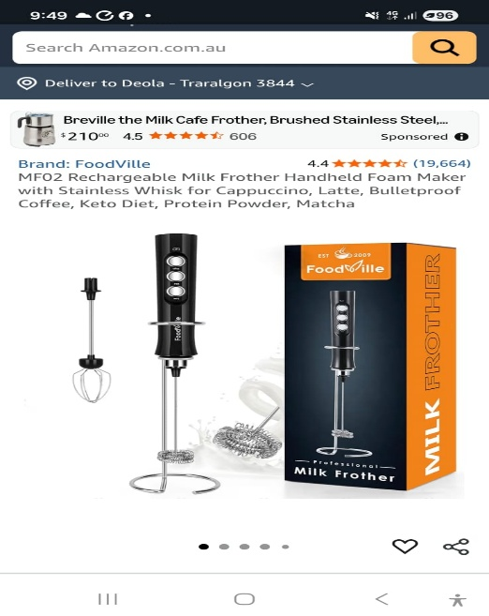
- Goal: The user's goal is to purchase an item from Amazon
- Plan: They check the Amazon website to order the item
- Specify: The desired item is selected
- Perform: The user interacts with the webpage, tapping the screen, inputting payment and confirming orders.
- Perceive: The user receives order confirmation and payment receipt
- Interpret: The user interprets the feedback to ensure the order is correct and the payment went through.
- Compare: The user evaluates their goal to see if the item received matches their experience.

Part 2:

a) User Story
- Account Registration and Login
User Story
As a new user, I want to create an account and log in securely, so that I can place orders and track my purchases.

Acceptance Criteria
- Users can register using email and password
- Users can log in securely using their registered credentials
- The system validates incorrect login details and displays an error message
- Users can reset their password if forgotten
- Login and registration should work smoothly on both Android and IOS devices

- Checkout and Payment
User Story
As a customer, I want to check out and pay securely through the app, so that my tea order can be processed and delivered to me.

Acceptance Criteria
- Users can review their order before confirming payment.
- Users can enter delivery address details.
- The system supports multiple payment methods.
- Users receive an order confirmation notification or email.

- Viewing and Adding Products to Cart
User Story
As a customer, I want to browse fresh tea leaves and add selected items to my cart, so that I can easily purchase the tea products I like.

Acceptance Criteria
- Users can view a list of available tea products with images and prices.
- Users can click on a product to view detailed descriptions.
- Users can select a quantity before adding the product to the cart.
- Users can see the updated cart total after adding items.
- Users can remove or change items in the cart before checkout.

- User Assistance Function
User Story
As a user who needs help, I want to contact customer support through the app, so that I can resolve issues to orders or the app.

Acceptance Criteria
- Users can access a help or support section within the app.
- Users can view frequently asked questions.
- Users can send a message or request help from customer support.
- Users receive confirmation that their support request has been received.
- The help section should be easy to locate and simple to use.

- Personalised Tea Recommendations
User Story
As a tea customer, I want to receive personalised tea recommendations, so that I can discover new teas that match my taste preferences.

Acceptance Criteria
- The system suggests tea based on previous purchases or browsing history
- Users can view recommended teas on the home screen.
- Users can add recommended teas directly to the cart.
- Recommendations should update as the user continues using the app.
- The feature should not slow down app performance.
b) Task Matrix

Reference
- Andersen, G. (2024, March 25). Measuring mobile UX design success - Key metrics and strategies for optimal user experience. Custom software development company. https://moldstud.com/articles/p-measuring-mobile-ux-design-success-key-metrics-and-strategies-for-optimal-user-experience

- ChatGPT

